**Snapshot SWOT Analysis**

**For Integrated Planning**

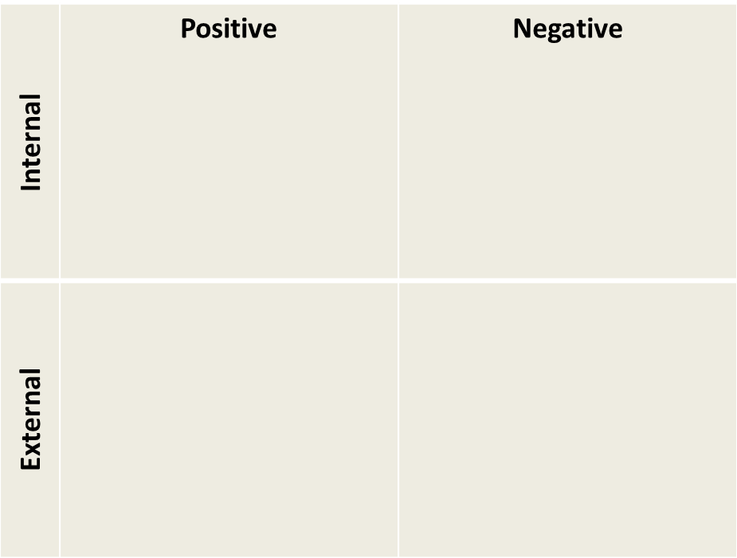

The SWOT analysis is a useful tool to determine Strengths, Weaknesses, Opportunities and Threats of an institution, group, department, etc. The internal aspects of the organization are addressed in Strengths and Weaknesses. Areas to explore include staffing, finances, processes, technology, etc. Meanwhile, Opportunities and Threats address external forces beyond the organization’s control, such as changing demographics, state or federal legislation, trends, etc.

In an integrated planning process, the SWOT analysis is often used as part of the development of the plan to set goals and objectives. However, it can also be utilized in the evaluation of the planning process itself, as the plan moves through each component of the IP Model. Using a SWOT analysis in this manner affords the institution a “snapshot” of the planning process as it is happening. Some colleges may already have a similar evaluation process in place, although it may not be specifically a SWOT analysis.

Since a planning cycle spans many years, the people tasked with evaluating the planning process at the end of the cycle may not all be the same group of people who were involved in the development of the plan. A snapshot SWOT analysis provides background for the new people, while refreshing the memories of those who were present at the beginning of the process.

Data from the snapshot SWOT analysis can be used to inform a comprehensive evaluation of the process at the end of the cycle. The data gathered also provide good evidence of continuous quality improvement that can be used for the accreditation self-evaluation report.

**How to use this tool:**

As the planning process moves from one component of the IP Model to the next, schedule a time for the planning committee to conduct a snapshot SWOT analysis for the recently completed component. The focus should be on that component only.

Develop questions to guide the committee members through the SWOT analysis. Some possible questions could be:

* Strengths
  + What did we do well?
  + What positive comments have we received?
  + What positive actions have we observed?
  + How did this improve the college?
* Weaknesses
  + What did not work and why?
  + What negative comments have we received?
  + What negative actions have we observed?
  + How has this weakened the college?
* Opportunities
  + How did the process give people a chance to collaborate?
  + Did the process generate a new way for people to work together?
* Threats
  + Are there any possible negative ramifications?
  + What is happening outside the college that might affect this process?

The committee may also want to note recommendations for improvement for the next planning cycle.

The snapshot SWOT analysis is not meant to be a comprehensive evaluation, so it should not take more than one meeting to complete. It could be discussed with the committee as a whole, or feedback could be solicited individually and then shared at the meeting. A third option is for the members to split into four groups and take one part of the analysis.

**IP Model Component: Discover**

This is an important but often overlooked component of an integrated planning process. The discovery phase allows a college to take a step back and evaluate how planning is done.

|  |  |
| --- | --- |
| **SWOT** | **IP Model Component: Discover** |
| Strengths |  |
| Weaknesses |  |
| Opportunities |  |
| Threats |  |

EXAMPLE:

|  |  |
| --- | --- |
| **SWOT** | **IP Model Component: Implement** |
| Strengths | A new, more integrated planning structure was developed, with better balance in representation |
| Weaknesses | Some people felt this process took too long; there were also comments that not enough faculty or staff were involved |
| Opportunities | The college had never engaged in this activity before, so many lessons were learned from reviewing the planning process and how to improve it; new opportunities for collaborations between departments were developed |
| Threats | The college was placed on warning by Accrediting Commission for not meeting some of the standards on planning; while we have made significant progress in this area, there is always a concern that it won’t be sufficient to lift the warning |

Recommendations for next planning cycle: have college-wide integrated planning workshop before the next plan is developed

**IP Model Component: Develop**

In this component, the focus is on the development of goals, measurable objectives, strategies, institution-set standards, etc.

|  |  |
| --- | --- |
| **SWOT** | **IP Model Component: Develop** |
| Strengths |  |
| Weaknesses |  |
| Opportunities |  |
| Threats |  |

EXAMPLE:

|  |  |
| --- | --- |
| **SWOT** | **IP Model Component: Develop** |
| Strengths | Many people were involved in the development of the plan. A concerted effort to get more participation from faculty and staff was successful. |
| Weaknesses | There is some concern that the goals and targets set are too lofty and we are setting up ourselves to fail |
| Opportunities | New funding opportunities (XYZ grants, ABC Funds) have become available that will greatly help to support the implementation of these goals. |
| Threats | The System Office is in the process of developing new definitions for certain metrics, as well as setting new targets, which might impact us. We might have to review and possibly revise our targets to align with these. |

Recommendations for next planning cycle: consult with IRP sooner in the process to help committee set targets

**IP Model Component: Implement**

This is the time for action, when the goals, objectives and strategies of the plan are operationalized.

|  |  |
| --- | --- |
| **SWOT** | **IP Model Component: Implement** |
| Strengths |  |
| Weaknesses |  |
| Opportunities |  |
| Threats |  |

EXAMPLE:

|  |  |
| --- | --- |
| **SWOT** | **IP Model Component: Implement** |
| Strengths | Prioritization process of resource requests developed and implemented; process as developed by and vetted through all stakeholders |
| Weaknesses | Some people who were not part of the development are still unsure how resources are prioritized and don’t trust it |
| Opportunities | Transparency of process allowed departments to see each other’s resource request; in some cases, departments were able to collaborate and find ways to share resources; a process to facilitate this is being explored |
| Threats | Although requests have been prioritized and approved to be funded, the budget has not been finalized, and there has been some indication that the budget may be cut |

Recommendations for next planning cycle: more training

**IP Model Component: Evaluate**

It is important to evaluate the progress towards goals on a regular basis, at least annually, but more frequently if needed. For multi-year plans, evaluation may lead to slight modifications of objectives and strategies.

|  |  |
| --- | --- |
| **SWOT** | **IP Model Component: Evaluate** |
| Strengths |  |
| Weaknesses |  |
| Opportunities |  |
| Threats |  |

EXAMPLE:

|  |  |
| --- | --- |
| **SWOT** | **IP Model Component: Evaluate** |
| Strengths | We completed evaluation after the 1st year of the plan and received 100% participation from departments and areas to provide progress reports |
| Weaknesses | We do not have a good way to track progress; departments or areas responsible for tracking the measurable objectives were using various methods and submitting their reports in different formats, making it very time-consuming to compile a uniformed report. |
| Opportunities | A new planning committee member shared a tool used at a previous institution which might be useful. The planning committee will review the tool for possible use to for next year’s evaluation. |
| Threats | None identified |

Recommendations for next planning cycle: provide tracking tool or templates

**IP Model Component: Report**

Once the evaluation is complete, it is important to share the results broadly.

|  |  |
| --- | --- |
| **SWOT** | **IP Model Component: Report** |
| Strengths |  |
| Weaknesses |  |
| Opportunities |  |
| Threats |  |

EXAMPLE:

|  |  |
| --- | --- |
| **SWOT** | **IP Model Component: Report** |
| Strengths | A dashboard was developed to track and report on the progress towards achievement of the goals and objectives. |
| Weaknesses | The dashboard was released without training faculty and staff on how to use it and how to interpret the data; sustainability of updating this annually has not been addressed |
| Opportunities | With additional training, faculty and staff will be able to understand the data; other dashboards may be developed as well; there may be some funding available for new software and also training |
| Threats | Since the dashboard is posted on the website, there is a risk of misinterpretation of the data. |

Recommendations for next planning cycle: more training; consider other software to create dashboards and reports