Evaluation in Integrated Planning
Leveraging the institutionalized monitoring system
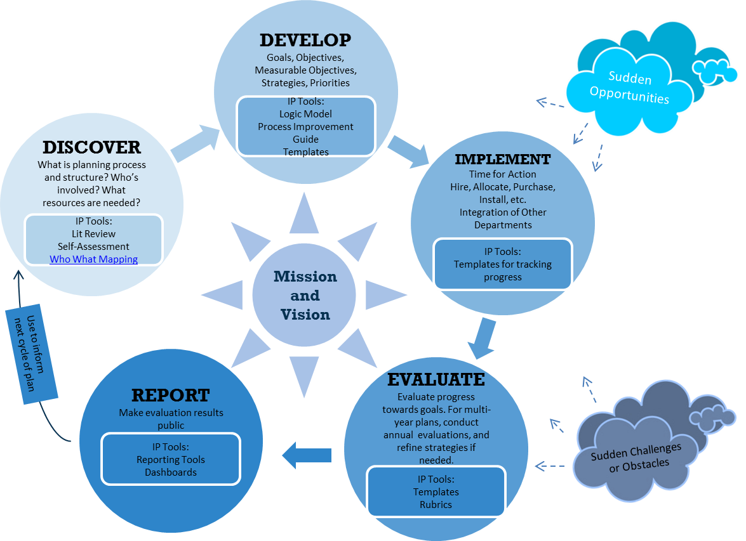
When it comes to making plans, evaluation is everywhere: evaluation in planning, evaluation and planning, evaluation of planning, and even—planning the evaluation. The preposition (i.e., in or of) can offer a hint as to the focus, but for the most part, these phrases do not offer much insight as to what the “evaluand” (the thing being evaluated) actually is. For instance, such a question may arise: “what should we be evaluating right now, and how?” This question can be clarified by focusing on the evaluation step in the prescribed Integrated Planning (IP) Model (see graphic below). The IP Model has five steps: 1) Discover, 2) Develop, 3) Implement, 4) Evaluate, and 5) Report. Here, evaluation can encompass a broad set of activities or things to evaluate, and these are highly contingent on the year or development of the plan/project that is underway; this document intends to clarify the utility of monitoring systems for evaluation purposes.

The Integrated Planning Model
- What are we supposed to evaluate in this step?

- How do we learn from monitoring systems?

When rearing towards a closeout period—typically a period of time that is much too short for significant, large-scale change—monitoring systems are utilized to examine progress and steer the course of action. But what does that mean? If our target metric is down in the slumps in year one we need to revise and refine everything? If not everything, how do we know what aspect of the plan (strategies, priorities, etc.) needs refinement? Routinely collecting data on implementation characteristics can take out some of the guesswork. Therefore, it may be advantageous for systems to be in place that collect data on not only the outcome(s) (something the institutional research office can readily accomplish), but the outputs as well— the services and activities delivered to students. This information, together, can serve rapid feedback purposes.

Suppose a new educational service to increase student success was implemented as part of a new program plan. At the end of the academic year, and after looking at the overall success rate, there appears absolutely no increase. Should we panic and declare: “No effect!” Let’s take a look at the generic logic model below, and determine how evaluation monitoring can be used in the early stages of plan implementation.
Combining monitoring data to maximize evaluation information
ACTIVITIES

OUTCOMES
Short Medium Long-Term
InPUTS

(OUTPUTS)
Educational service to increase student success
Course Success GPA Increase Completion
Students attend support service
New Plan

1
3
2

4
2
Process monitoring routinely collects data pertaining to implementation. This means data such answering question such asks:
- Was the new support service implemented correctly?
- How many sessions did students attend?
- Are we reaching the students we want to with this activity/service?

Outcome monitoring routinely collects data on the outcome of interest, and can be used to answer:
- What are the indicators of success?
- Are participants exhibiting progress?
- Should operations be adjusted accordingly?

- Collect and monitor data relevant to the output.
- Ensure implementation is going according as planned; see if the target outcome measure is following suit (not a causal analysis).
- Assess the discrepancy between processes and outcomes and make any changes or refinements necessary to bring about the desired outputs.
- Monitor the outcome measure, then, check on outputs to examine consistency with the model’s logic (between outputs and outcomes).
Starting Point = Collect/monitor data
Starting Point = Ensure/assess congruency in data

References
- Chen, H. T. (1990). Theory-driven evaluations. Sage.
- Chen, H. T. (2014). Practical program evaluation: Theory-driven evaluation and the integrated evaluation perspective. SAGE Publications.

