Planning a Program Evaluation on Your Campus

What are the must-haves and nice-to-haves in a program evaluation?

What is Program Evaluation?
Program evaluation is the systemic method of collecting, analyzing, and using information to answer questions about a program or projects.
An evaluation can be small (one program) or large (many programs across the campus)
Programs can include small boutique programs (e.g., student mentoring programs), large institutional programs (e.g., tutoring on campus), categorically funded programs (METRO, EOPS, and Guardian Scholars), academic programs (e.g., English department course track), and more.
There are many technical terms for different types of evaluations that you may have heard of. Some of them are identified and defined below.
Formative Evaluation | Process Evaluation | Summative Evaluation
Evaluation of a program during program development to improve the program | Evaluation of the program’s processes during the implementation to improve effectiveness | Evaluation of the outcomes of the program to learn about program effectiveness

The technical terms are not as important as the questions you are trying to answer, such as:
- Is there a need?  - Where is the need? | - Is the program implemented as intended?  - What barriers are affecting the program?  - Do processes need improvement? | - Was the program effective?

Or the possible reasons for an evaluation, such as:
- Support a funding request | - Improve, expand, or refocus the program | - Report results of a program

Steps to Planning an Evaluation on Your Campus

STEP 1: Define the Program
An understanding of the program by the evaluators is a must-have. Whether the program is being evaluated by the program personnel, the research office on campus/district, or an external evaluator, a clear understanding of the program is necessary to plan an evaluation.
To understand a program, think about the following questions:
- What are the goals of the program?
- What are the intended outcomes?
- What are the activities of the program?
- Whom does the program serve?
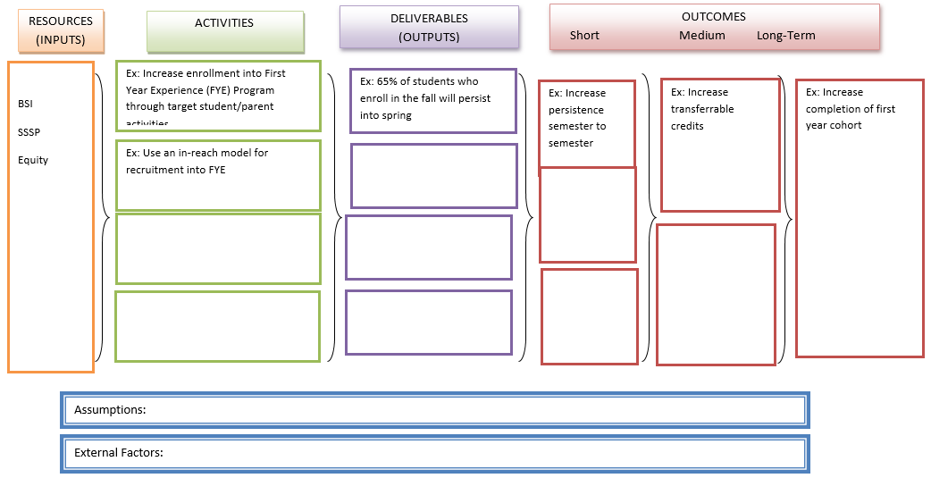
A logic model may be useful in defining the program. A logic model would be nice to have during the evaluation process. A logic model maps out and links the inputs, activities, outputs, and outcomes of a program.

STEP 2: Identify the Stakeholders
Identifying stakeholders is a must-have in an evaluation. Identifying the stakeholders can help determine and clarify goals of the program.

What is a Stakeholder?
Stakeholders include anyone (person or funder) who has a vested interest in the program or is affected by the program. Stakeholders could include students, faculty, staff, administrators, internal and external funders, partners in the community, and shared governance bodies (e.g., Academic Senate).

Stakeholder Support
Include stakeholders in the evaluation process and give them an opportunity to feel a part of or ownership of the evaluation process. Stakeholders support is a nice-to-have. Although stakeholder support is not a necessity, it can greatly help with the evaluation process.

How Can Ownership from Stakeholders Help the Evaluation Process?
- Reduce resistance. Stakeholders will be more willing to participate if they feel they are part of the evaluation process and interested in the outcomes of the evaluation. Some stakeholders may need to be a part of the evaluation process (e.g., data collection, filling out surveys, or signing into a tracking system) and will be more likely to participate if they feel their voices are heard and believe the evaluation will be useful.
- The use of the results. The intention of an evaluation is to use the results of the evaluation. By bringing stakeholders into the evaluation process and working with them to build a sense of ownership ahead of time, stakeholders will be more likely to anticipate and look forward to the results of the evaluation. If stakeholders are not invested in the evaluation, the results of the evaluation may not be used.

STEP 3: Identify the Evaluation Questions
Think about what you want to learn from the evaluation and why.
Possible questions to consider when developing evaluation questions:
- How should the program run day-to-day?
- What are the intended outcomes of the program?
- What data can be collected?

Evaluation questions that can be measured are a must-have for evaluation. There are many questions that may be interesting to answer, but not all of the questions are answerable.

The goal is to place your question(s) here. Find something measurable that tells you more about something you want to know.

Questions We Can Answer | Questions We Cannot Answer
Are the students succeeding in their classes?  - Are my students more likely to persist?  - What are the demographics of the service population?  - Is there an equity gap? | How does my program affect my student’s family life five to ten years from now?  - Will working adults do better in the program if all of the courses are offered online next semester?

STEP 4: Data Collection
The must-haves of data collection are:
- Identify what type of data will answer your evaluation questions; and
- Identify your sample.
An additional nice-to-have is:
- Create a timeline for when to collect the data.

Data Types
Data to answer the evaluation questions can come in many forms. The data type will vary depending on your question and the data already available on your college campus. There are two main types of data, as described below.
Quantitative Data | Qualitative Data
What types questions can it answer:
- What?  - How much?  - How many? | - Why?  - How?
Where/how to collect the data:
- Existing college database  - Database generated specifically for the program  - Other systems, such as AccuTrak or Starfish | - Surveys  - Interviews  - Focus groups  - Content review

Data Collection Tip: Check in with the Research Office on Your Campus
- The research office may know of existing data sources on campus. The college database may already contain demographics, course success, enrollment, and headcount. You may not have to collect this data or look it up one student at a time.
- The research office may be able to help streamline your data collection process.
- The research office may have analysts who are skilled at creating surveys or running focus groups and may be able to help.

Sample
The sample is the target population you want to include in the evaluation.
When selecting a sample, consider the following:
- Who is the target population of your program?
- Who participated in the program?
- What students did not participate? Should they be included in the sample?
- The size of the sample:
  - A large sample size is ideal for quantitative data or generalizing the outcomes.
  - A smaller sample more manageable with qualitative methods such as focus groups.
- Do you need a comparison group?

Timeline
When will you start your activities, and when will you evaluate the program? Ideally, the planning of an evaluation will begin during the planning or development stage of a program.
Try integrating the evaluation timeline into the timeline of the program itself. A timeline can help ensure data collection happens on time.
Activities | Year 1 | Year 2 | Year 3
Program Activities:
Hire staff | ----X
Train staff | -----X | -X | -X
Recruit students | ------X
Hold tutoring workshops | X X | X X X | X X X
Evaluation Activities
Plan the evaluation | ----X
Identify students in need | ----X
Collect student IDs | X X | X X X | X X X
Collect student grades | X | X | X

The data collection activities (data type, sample, and timeline) do not happen in silos. The timeline is dependent on the program, the questions you are trying to answer, and the data type.
Data type examples | Retention - Do students stay enrolled in the course? (no W) | Success - Do students pass the course? (A, B, C, P) | Progression - Do students move on to the next course in the sequence?
Timeline for collection and reporting | Fast – available after the semester is over | Fast – available after the semester is over | Takes more time –need to wait a year. Give students more than one semester to progress.
Sample | Available by course or cohort | Available by course or cohort | Available by course or cohort

STEP 5: Analyze & Interpret
This is when you interpret the results of the data you collected, draw conclusions about your program, and report out the results.

Analyze and Interpret
We can answer or start to answer key questions, including:
- Did it work?
- What are the strengths and weaknesses?
- Can we improve?
- Should we change or expand?
Identify the important findings and determine how the findings can be used for improvement.

STEP 6: Report the Results and Ensure Use
You put a lot of work into the evaluation. Report the results to help ensure the use of those results to improve, expand, or continue funding your program.
Consider your audience when reporting the results. A report or presentation to students on campus will be very different from a report or presentation to funders.
 | Possible report options
Audience | Report | Presentation e.g. PowerPoint | Flyer or handout | Website
A technical or formal audience
Students
Faculty and staff not familiar with the program
External stakeholders outside of the college

STEP 7: Congratulate Yourself and Start Planning the Next Program Evaluation
Evaluations are a continual process. As the program continues, grows, or changes, so should the evaluation plan and design.

References
Chen, H. T. (2014). Practical program evaluation: Theory-driven evaluation and the integrated evaluation perspective. SAGE Publications.

