**Introduction**

Planning calendars from 50 strategic plans, educational master plans, facilities master plans, and technology master plans were analyzed from community colleges across California. This tool includes planning calendar examples and templates.

Examples of calendars that colleges built and blank templates can be found below.

**Table of Contents**

## Activity by Date Planning Calendar

Examples from CCC 2-4

Blank Template 5

## Activity by Date and Description Planning Calendar

Examples from CCC 6-7

Blank Template 8

## Goal Planning Calendar

Examples from CCC 9-12

Blank Template 13-14

## Master Plan Timeline

Examples from CCC 15-19

Blank Template I 20

Blank Template II 21-23

## Program and Budget Timeline

Examples from CCC 24-25

Blank Template 26-27

## Gantt Chart

Examples from CCC 28-30

Blank Template 31-32

## Flow Chart

Examples from CCC 33

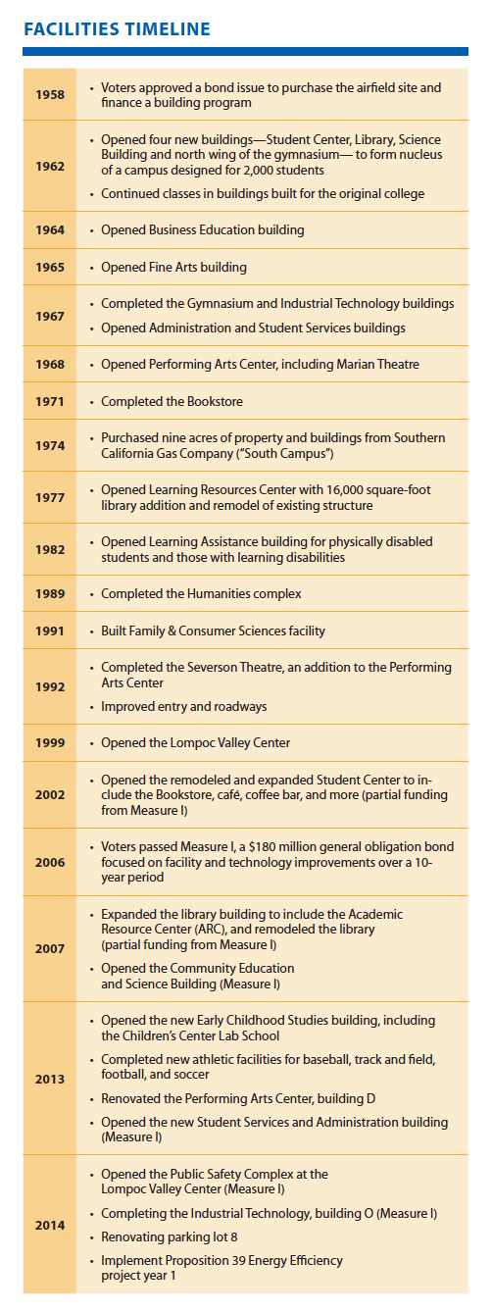

Allan Hancock SMP pg 25

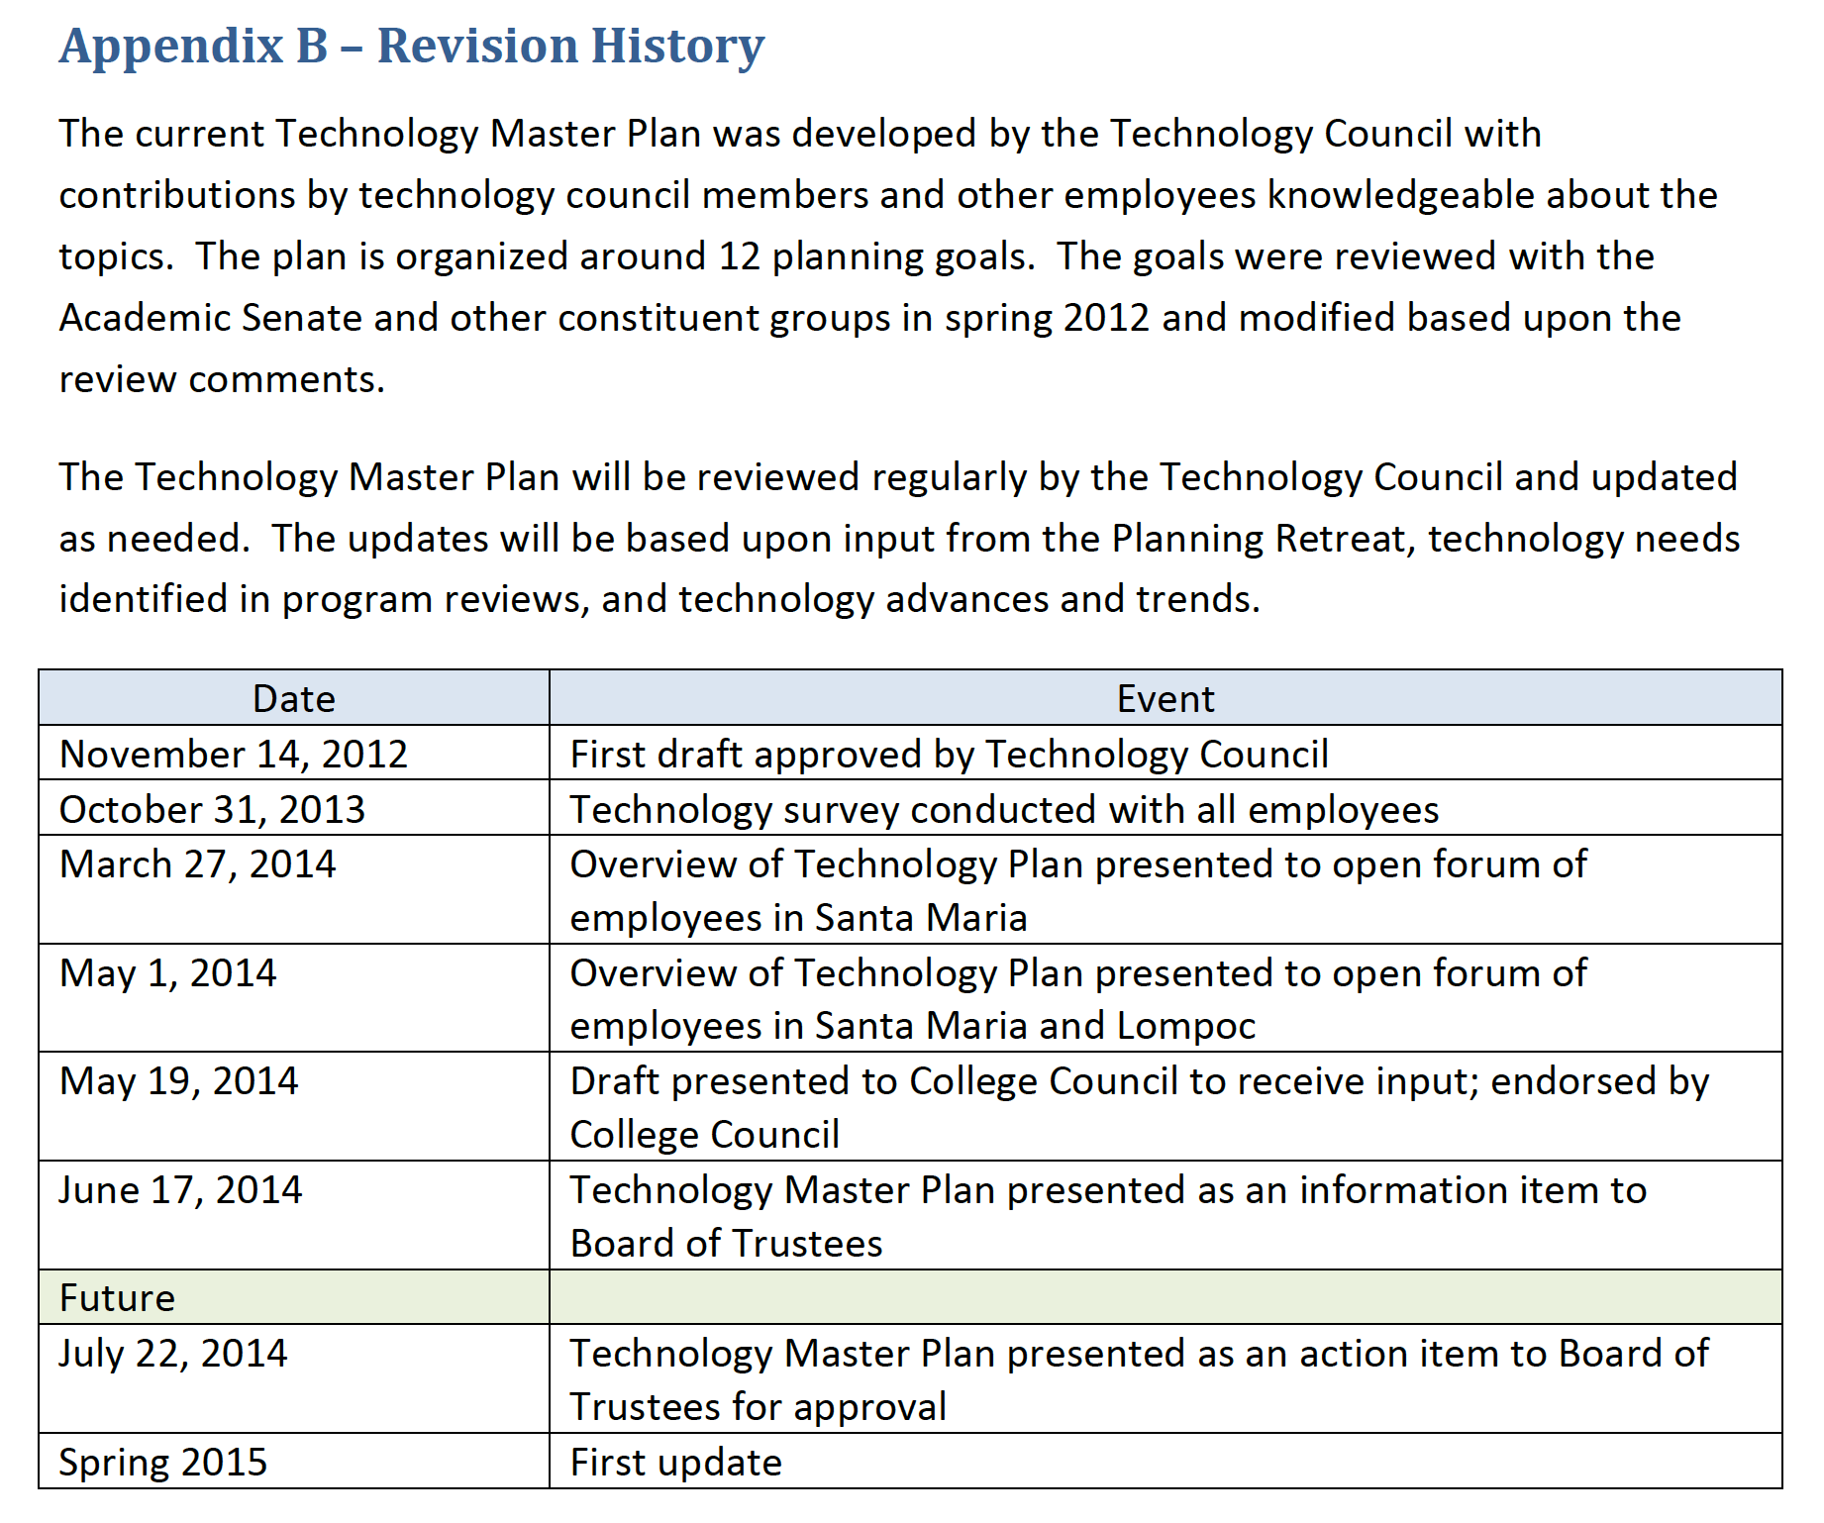

Allan Hancock ITMP pg 21

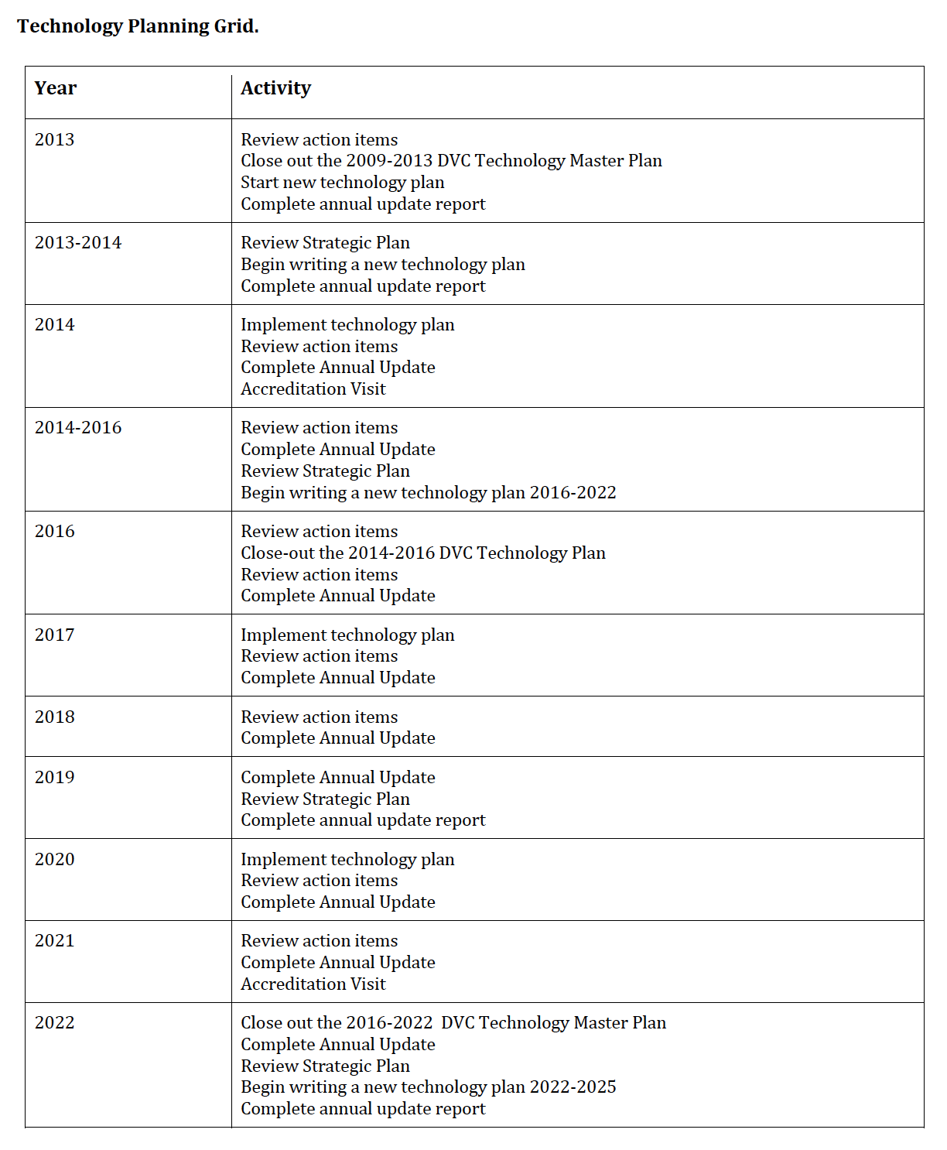

DVC ITMP pg 27

# Activity by Date Planning Calendar

Use this calendar to show a broad overview of an activity or planning processes/activities.

Change the heading titles to fit your college’s planning needs

|  |  |
| --- | --- |
| Date | Activity |
| *Insert date (YYYY, Month-DD-YYYY)* | *Insert planning activity with as much detail as needed* |
|  |  |
|  |  |
|  |  |
|  |  |
|  |  |
|  |  |
|  |  |
|  |  |
|  |  |
|  |  |
|  |  |
|  |  |
|  |  |
|  |  |

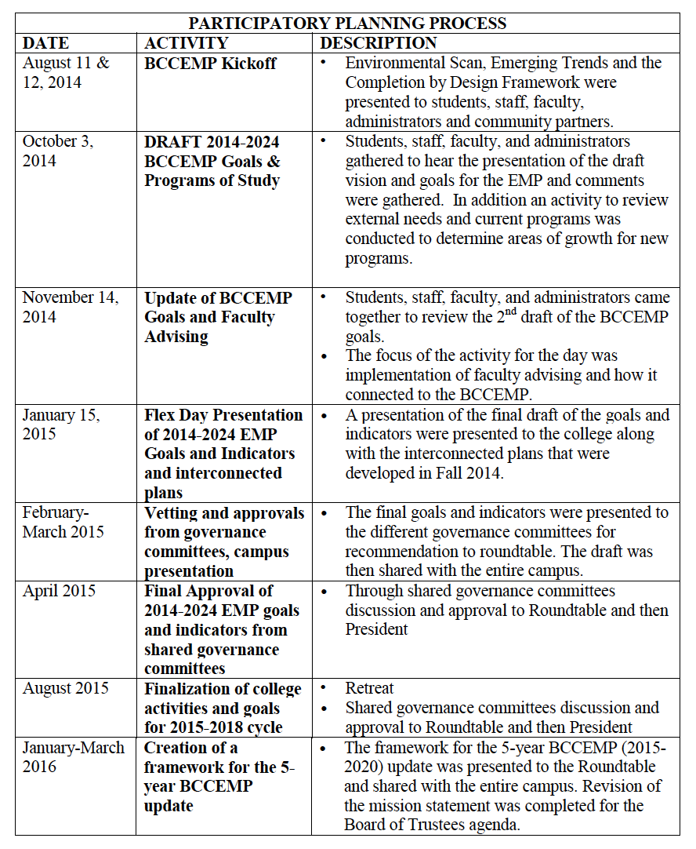

Butte ITMP pg 8

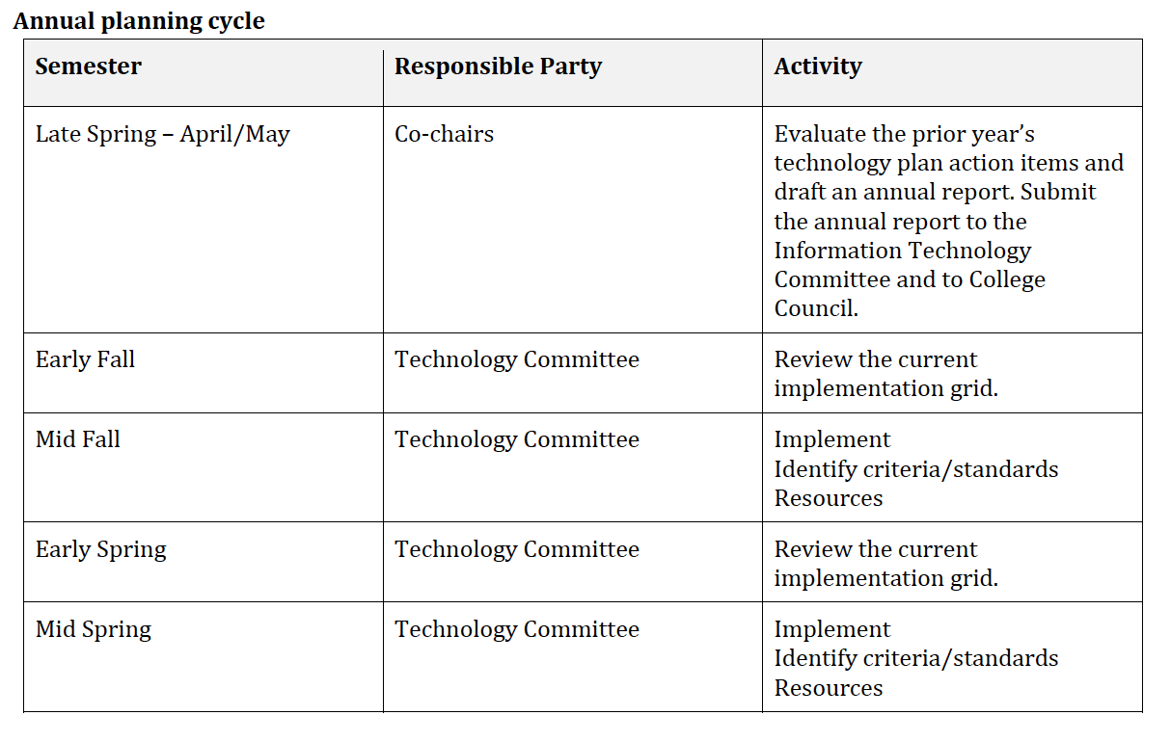

DVC ITMP pg 26

# Activity by Date and Description Planning Calendar

Use this calendar to show a broad overview of an activity or planning processes/activities with description added

Change the heading titles to fit your colleges planning needs

|  |  |  |
| --- | --- | --- |
| Date | Activity | Description |
| *Insert date (YYYY, Month-DD-YYYY)* | *Insert planning activity* | *Describe planning activity* |
|  |  |  |
|  |  |  |
|  |  |  |
|  |  |  |
|  |  |  |
|  |  |  |
|  |  |  |
|  |  |  |
|  |  |  |

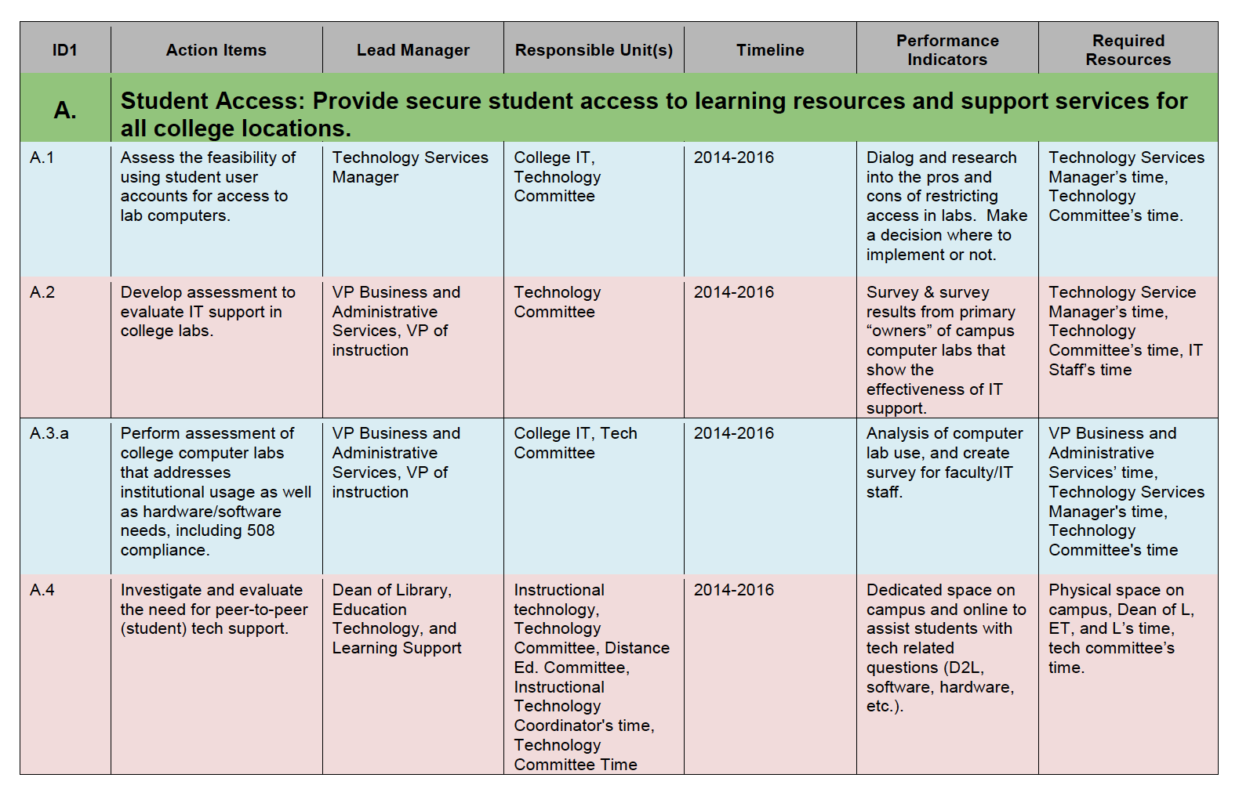

DVC ITMP pg 12-25

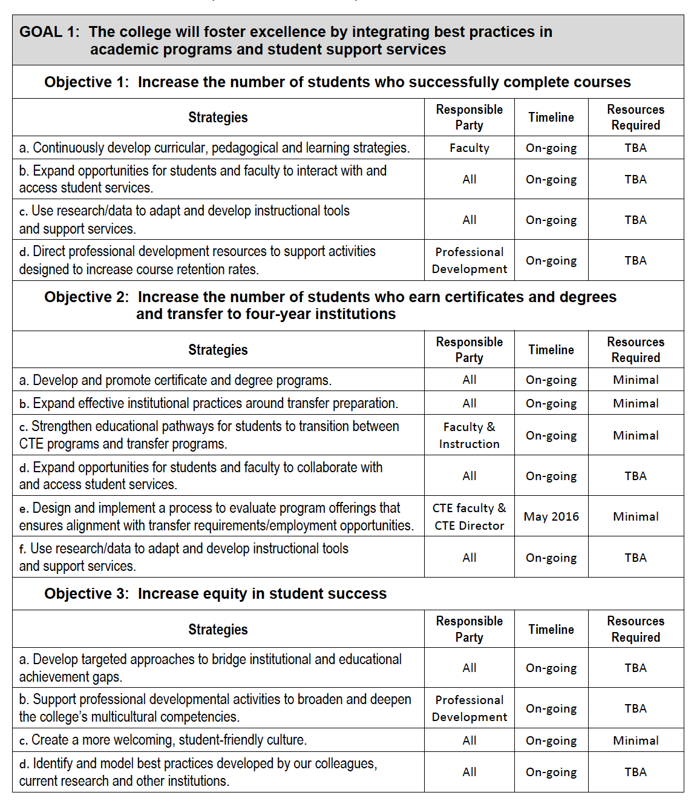

DVC SMP pg 23

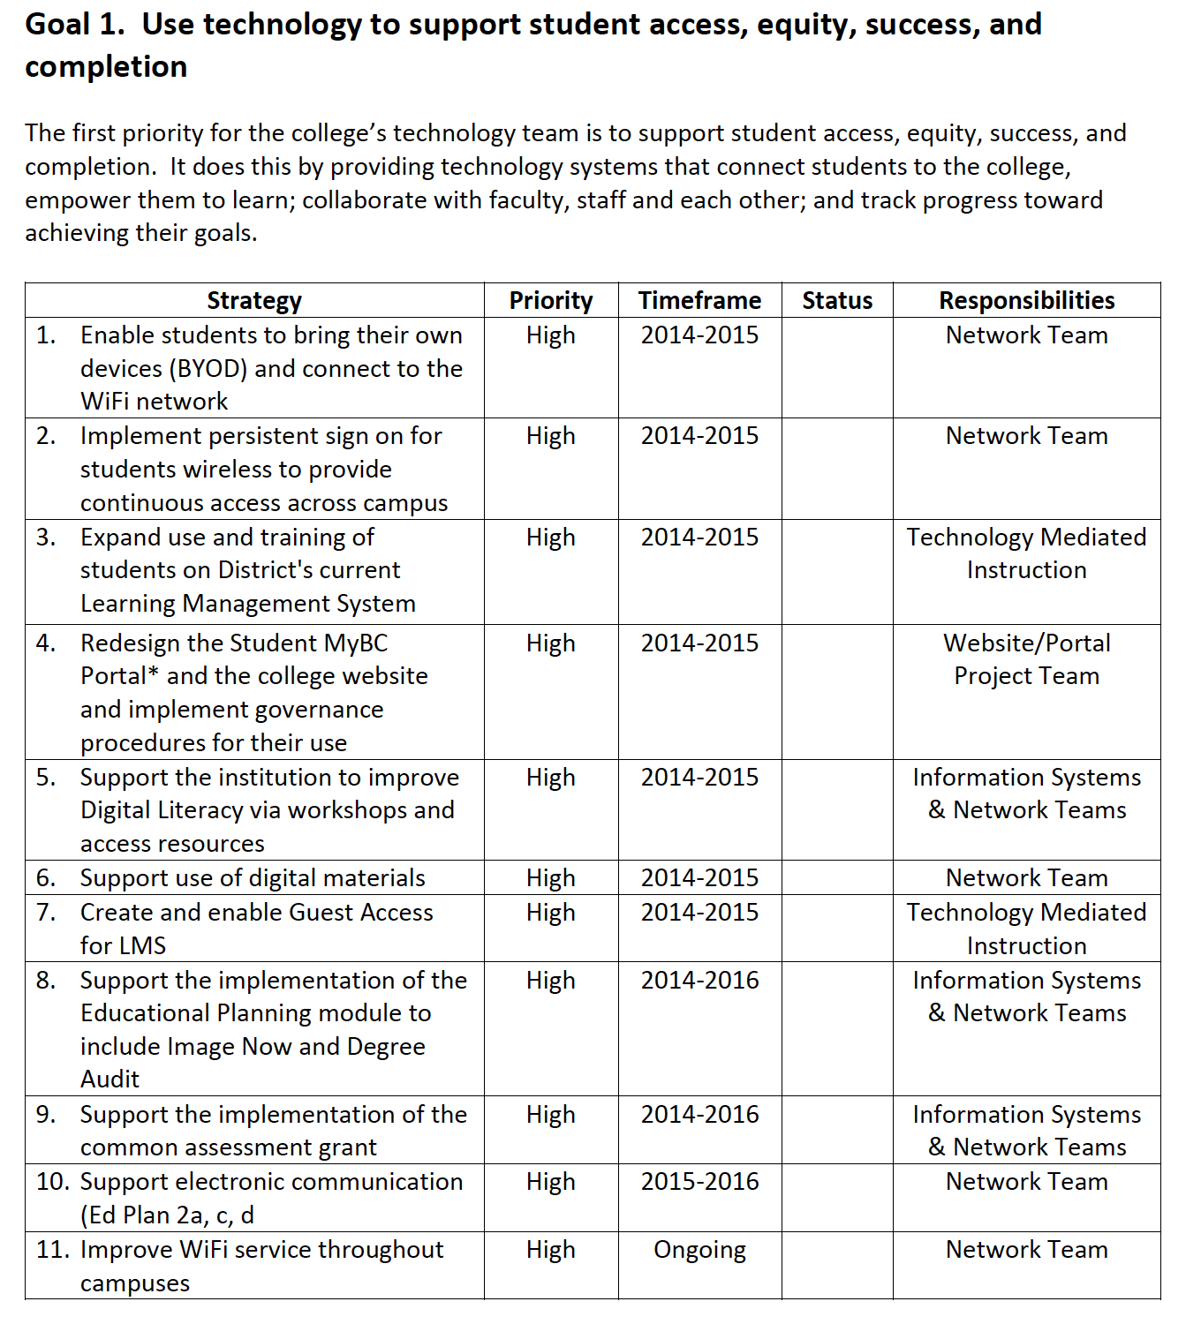

Canada EDMP pg 8

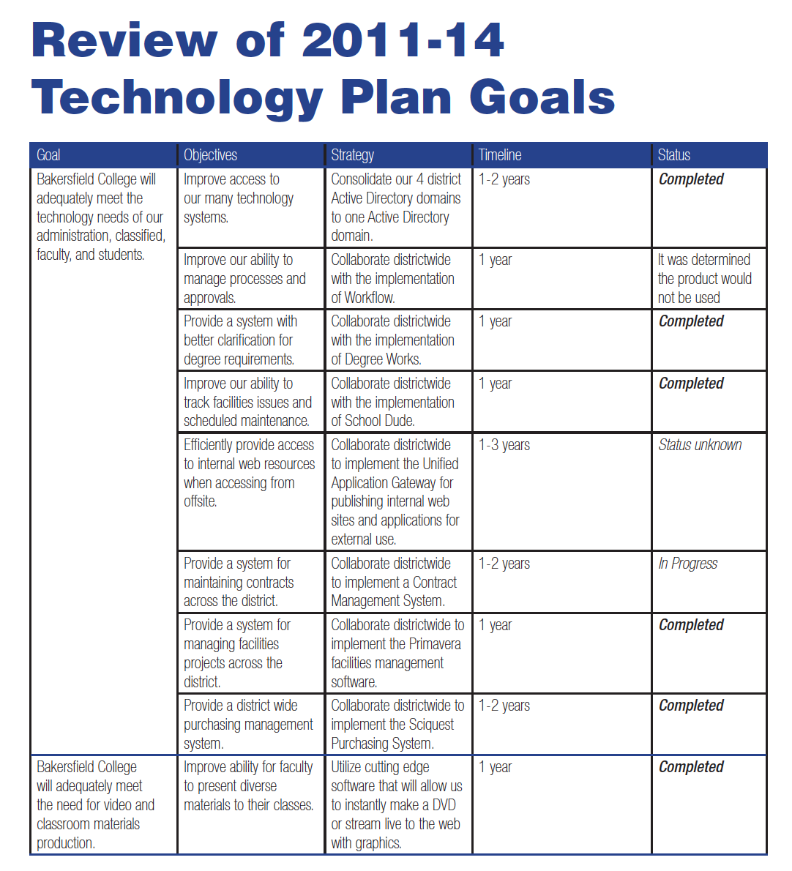

Bakersfield PG 8-10

# Goal Planning Calendar

Use this type of calendar when you need to show more details to the planning process.

Change the heading titles to fit your colleges planning needs

|  |  |  |  |  |
| --- | --- | --- | --- | --- |
| GOAL 1: Insert goal here *Enter in objectives or description of the goal* | | | | |
| **Strategies** | **Responsible Party** | **Resources** | **Timeline** | **Status** |
| *Insert actions or strategies here* | *Who is responsible?* | *What resources are needed to complete the strategy?* | *Insert dates* | *High/ Med/ Low* |
|  |  |  |  | *Complete/ In Progress* |
|  |  |  |  |  |
|  |  |  |  |  |
|  |  |  |  |  |
|  |  |  |  |  |

|  |  |  |  |  |
| --- | --- | --- | --- | --- |
| GOAL 2: Insert goal here *Enter in objectives or description of the goal* | | | | |
| **Strategies** | **Responsible Party** | **Resources** | **Timeline** | **Status** |
|  |  |  |  |  |
|  |  |  |  |  |
|  |  |  |  |  |
|  |  |  |  |  |
|  |  |  |  |  |
|  |  |  |  |  |
| GOAL 3: Insert goal here *Enter in objectives or description of the goal* | | | | |
| **Strategies** | **Responsible Party** | **Resources** | **Timeline** | **Status** |
|  |  |  |  |  |
|  |  |  |  |  |
|  |  |  |  |  |
|  |  |  |  |  |
|  |  |  |  |  |
|  |  |  |  |  |

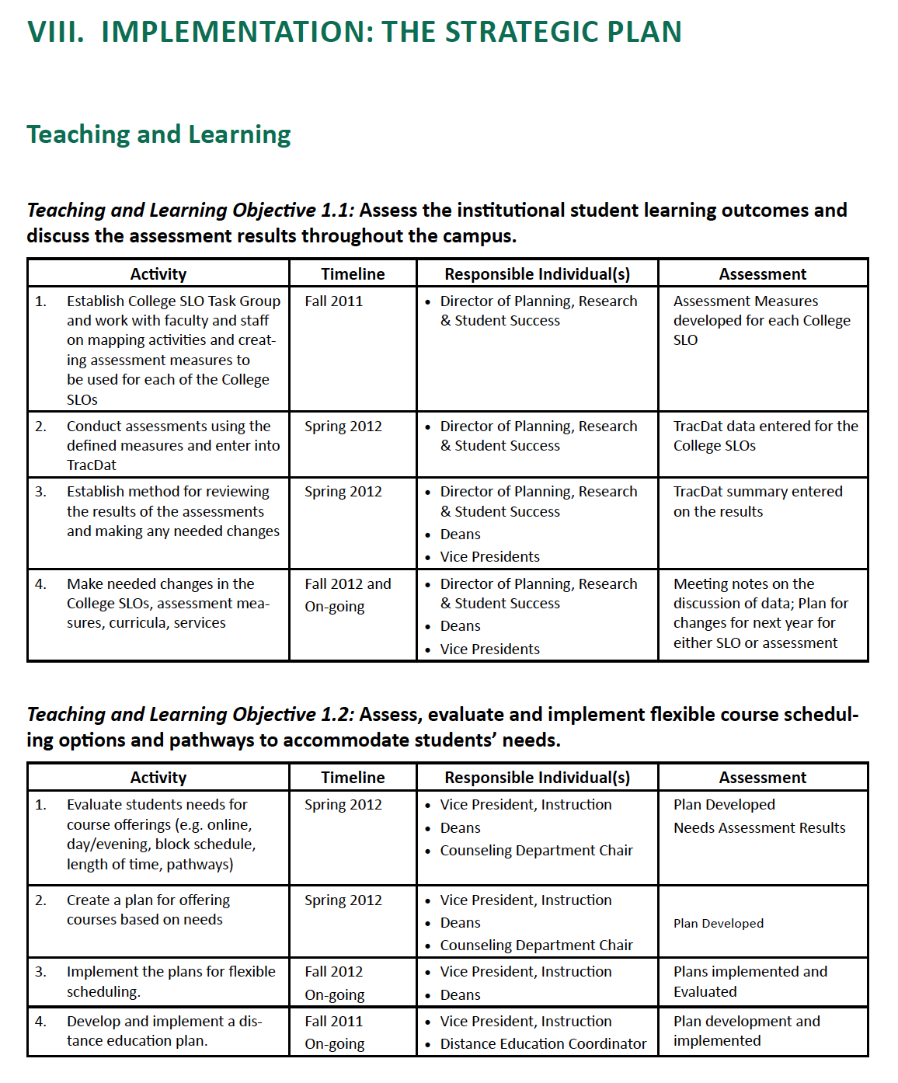

Canada Edmp pg 21-23

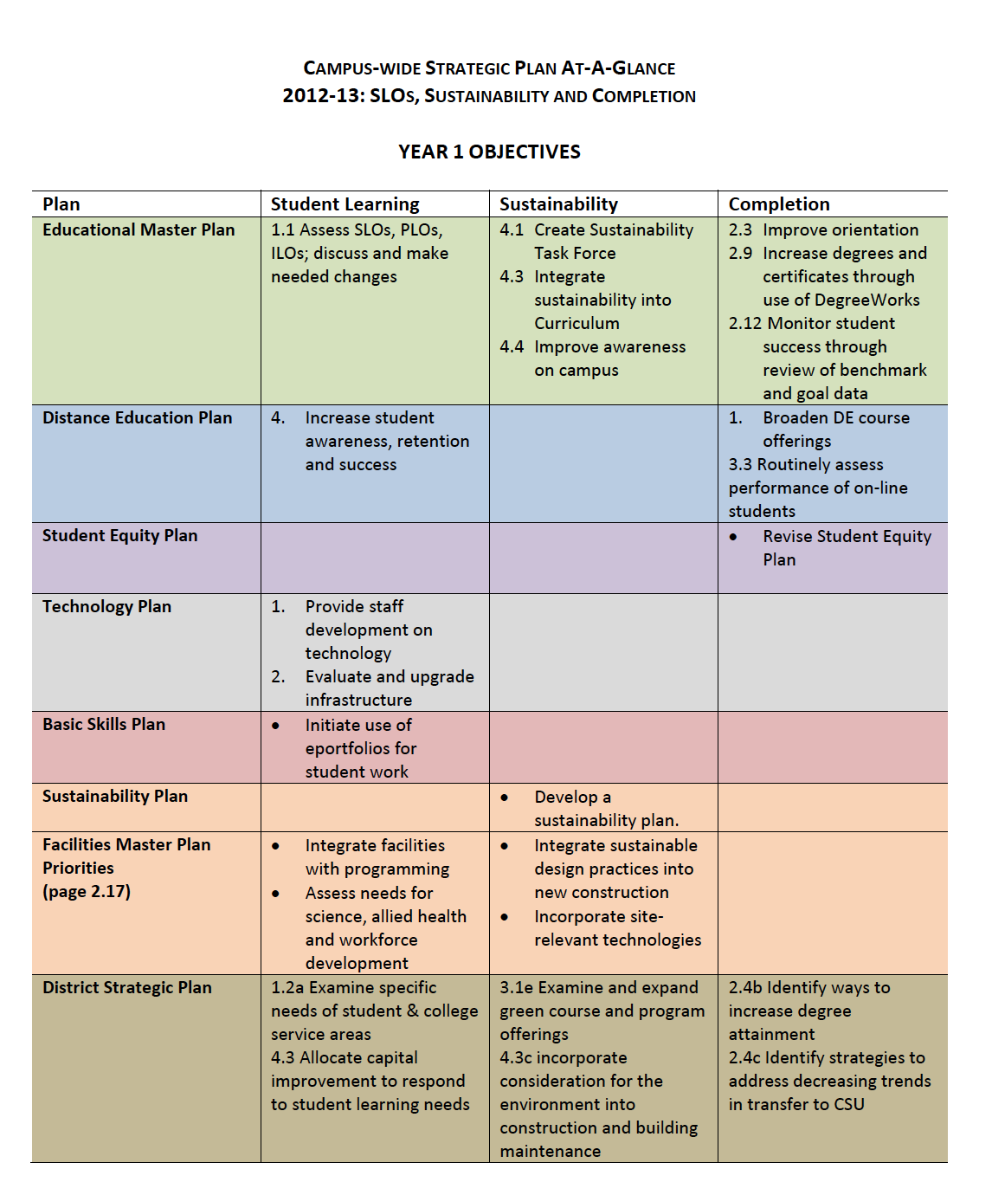

Canada SMP pg 2-3

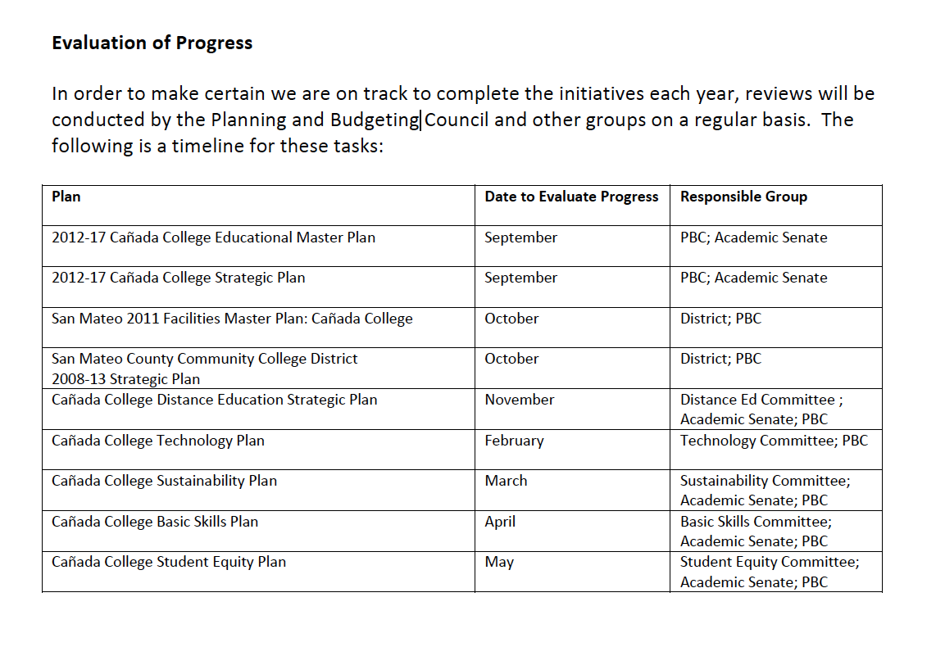

Canada SMP pg 7

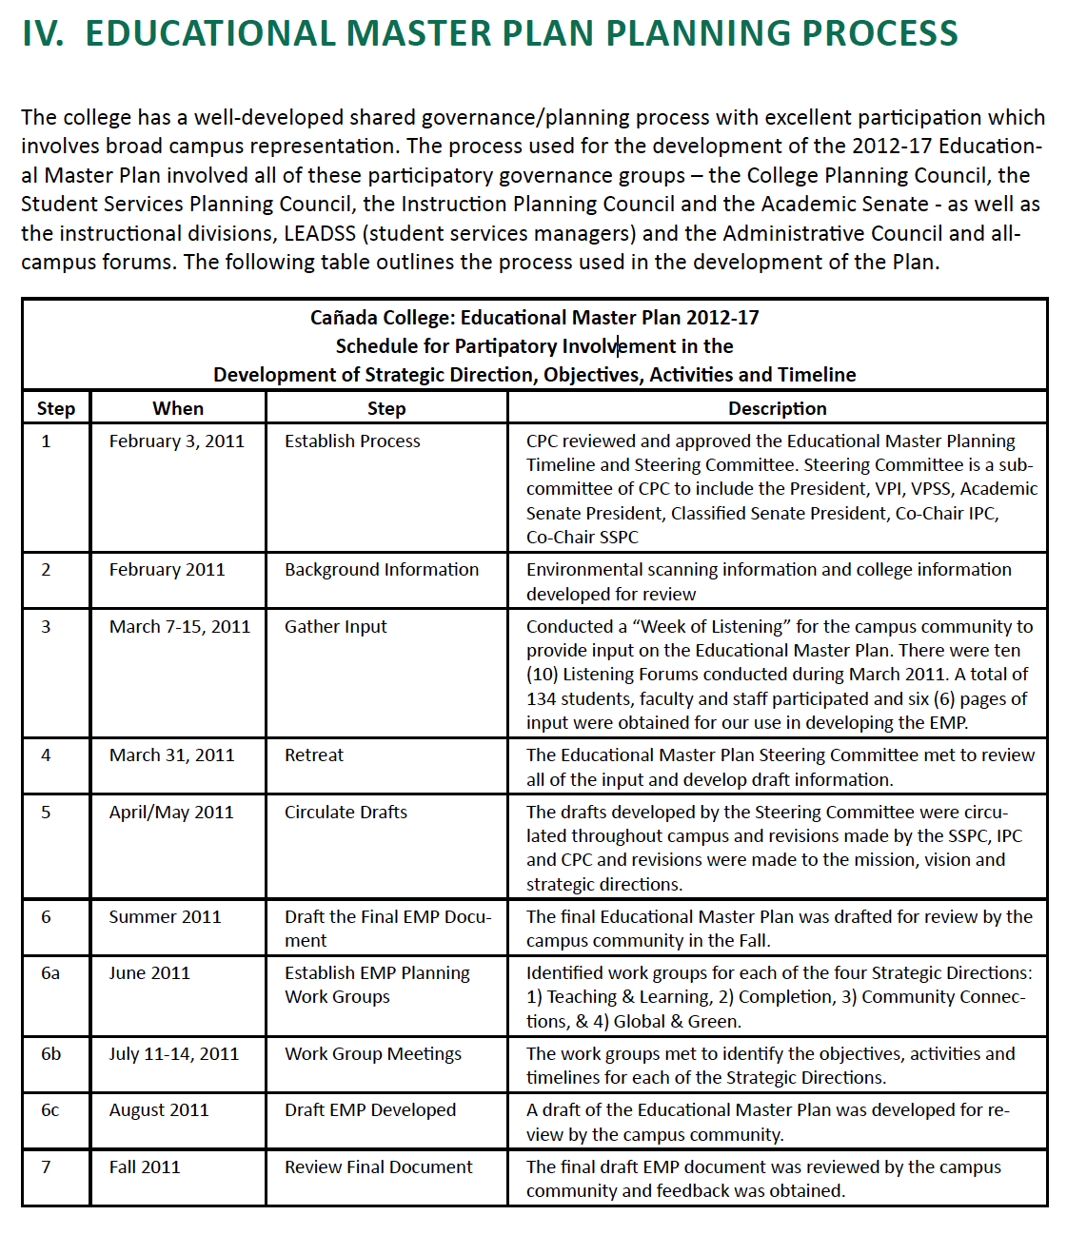

Canada Edmp pg 21-23

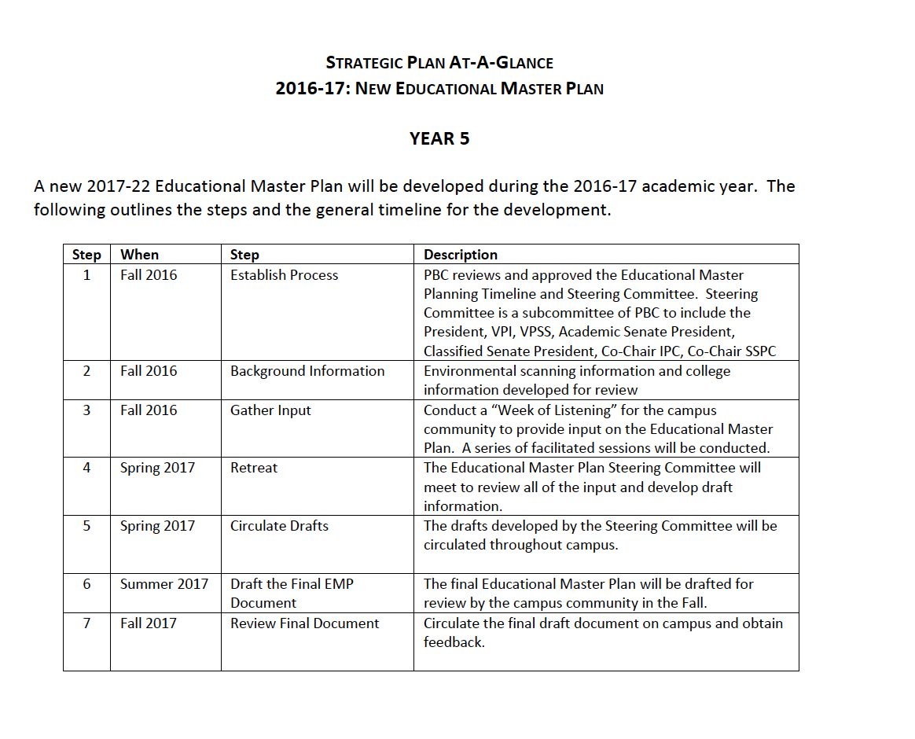

Canada SMP pg 6

# Master Plan Timeline I

There are many steps to creating or updating a master plan on a community college campus. Use this planning calendar to help lay out or keep track of the master plans timelines.

Change the heading titles to fit your colleges planning needs

|  |  |  |  |  |
| --- | --- | --- | --- | --- |
| Master Plan Title | Activity | Timeline | Responsible Party | Description |
| *Insert Master Plan Name* | *Insert activity or process* | *MM-DD-YY/YYYY/Month* | *Who is responsible?* | *Description of activity or process* |
| *Educational Master Plan* | *Create draft* | *March to May* | *Instruction* | *Assigned subgroups on campus collected and wrote drafts of each section. Office of Instruction to incorporate into one cohesive plan.* |
| *Strategic Plan* | *Present to Board* | *September 23, 2017* | *Office of Planning and Development* | *Board to review and approve or send back with edits.* |
| *Technology Master Plan* | *Evaluate* | *June 2017* | *Information Technology* | *Yearly evaluation of the plan* |
|  |  |  |  |  |
|  |  |  |  |  |
|  |  |  |  |  |
|  |  |  |  |  |
|  |  |  |  |  |

# Master Plan Timeline II

There are many steps to creating or updating a master plan on a community college campus. Use this planning calendar to help lay out or keep track of the master plans timelines.

Change the heading titles to fit your colleges planning needs

|  |  |  |  |  |
| --- | --- | --- | --- | --- |
| Educational Master Plan | | | | |
| **Activity** | **Responsible Party** | **Description** | **Timeline** | **Status** |
| *Writing team assembled* | *Writing teams* | *Writing teams formed and future meeting dates planned* | *Sep 2016* | *Complete* |
| *Research collected* | *Writing teams* | *Writing teams work with multiple departments on campus to collect needed information* | *Sep – Jan 2016* | *In progress* |
| *Initial draft created* | *Writing teams* | *First draft written and reviewed by the Office of Instruction* | *Jan 2016* | *In progress* |
| *Final draft* | *Writing teams* | *Final draft written and reviewed* | *March 2016* | *TBD* |
| *Present to president and board* | *Office of Instruction* | *Present to the president and board to be approved* | *June 2016* | *TBD* |
| *Evaluate* | *XYZ committee* | *Bi-yearly evaluation* | *Sept 2017* | *TBD* |
| *Review evaluation and update* | *XYZ committee and writing teams* | *Yearly update* | *Dec 2017* | *TBD* |

|  |  |  |  |  |
| --- | --- | --- | --- | --- |
| Educational Master Plan | | | | |
| **Activity** | **Responsible Party** | **Description** | **Timeline** | **Status** |
| *Insert actions or strategies here* | *Who is responsible?* | *Description of activity or list of resources needed* | *Insert dates* | *High/ Med/ Low* |
|  |  |  |  | *Complete/ In Progress* |
|  |  |  |  |  |
|  |  |  |  |  |
|  |  |  |  |  |
|  |  |  |  |  |

|  |  |  |  |  |
| --- | --- | --- | --- | --- |
| Technology Master Plan | | | | |
| **Activity** | **Responsible Party** | **Description** | **Timeline** | **Status** |
| *Insert actions or strategies here* | *Who is responsible?* | *Description of activity or list of resources needed* | *Insert dates* | *High/ Med/ Low* |
|  |  |  |  | *Complete/ In Progress* |
|  |  |  |  |  |
|  |  |  |  |  |
|  |  |  |  |  |
|  |  |  |  |  |

|  |  |  |  |  |
| --- | --- | --- | --- | --- |
| Facilities Master Plan | | | | |
| **Activity** | **Responsible Party** | **Description** | **Timeline** | **Status** |
| *Insert actions or strategies here* | *Who is responsible?* | *Description of activity or list of resources needed* | *Insert dates* | *High/ Med/ Low* |
|  |  |  |  | *Complete/ In Progress* |
|  |  |  |  |  |
|  |  |  |  |  |
|  |  |  |  |  |
|  |  |  |  |  |

|  |  |  |  |  |
| --- | --- | --- | --- | --- |
| Strategic Plan | | | | |
| **Activity** | **Responsible Party** | **Description** | **Timeline** | **Status** |
| *Insert actions or strategies here* | *Who is responsible?* | *Description of activity or list of resources needed* | *Insert dates* | *High/ Med/ Low* |
|  |  |  |  | *Complete/ In Progress* |
|  |  |  |  |  |
|  |  |  |  |  |
|  |  |  |  |  |
|  |  |  |  |  |

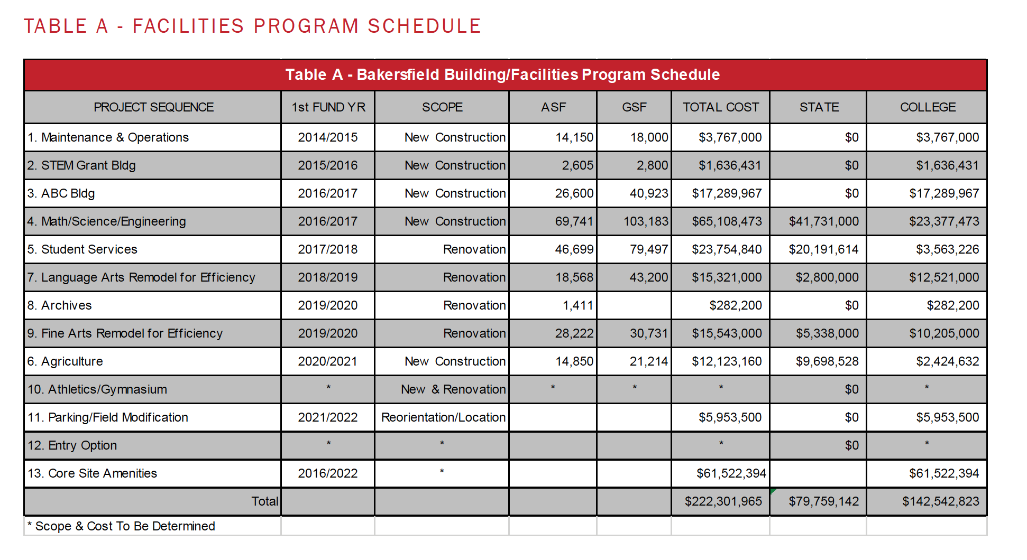

Bakersfield FMP pg 18

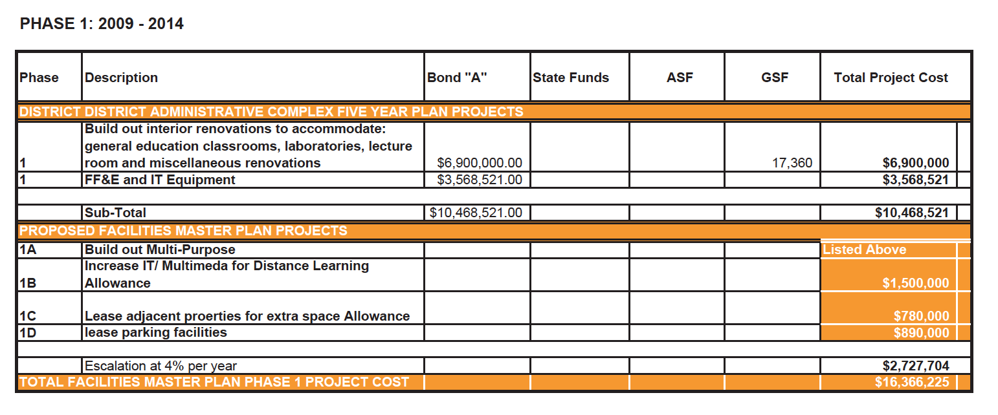

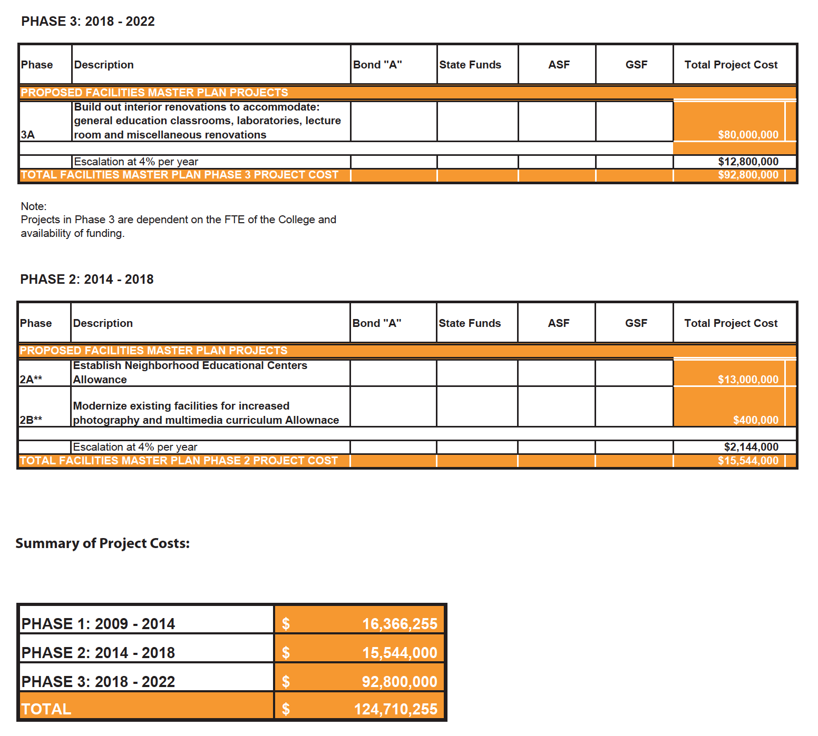

Berkely FMP pg 52-53

# Program Budget Timeline I

Use this timeline to organize when and where funding comes from for programs or projects.

Change the heading titles to fit your colleges planning needs.

|  |  |  |  |  |  |  |  |  |
| --- | --- | --- | --- | --- | --- | --- | --- | --- |
| Program | Timeline | Description | Funder 1 | Funder 2 | Funder 3 | Funder 4 | Funder 5 | Total Amount |
| Program | YYYY-YYYY |  | $$$ | $$$ | $$$ | $$$ | $$$ | $$$$$$ |
| Task | MM-YY |  |  |  |  |  |  |  |
| Task | MM-YY |  |  |  |  |  |  |  |
| Program |  |  |  |  |  |  |  |  |
| Task |  |  |  |  |  |  |  |  |
| Task |  |  |  |  |  |  |  |  |
| Task |  |  |  |  |  |  |  |  |
|  |  |  |  |  |  |  |  |  |
|  |  |  |  |  |  |  |  |  |
|  |  |  |  |  |  |  |  |  |
|  |  |  |  |  |  |  |  |  |
|  |  |  |  |  |  |  |  |  |
|  |  |  |  |  |  |  |  |  |
|  |  |  |  |  |  |  |  |  |
|  |  |  |  |  |  |  |  |  |

# Program Budget Timeline II

|  |  |  |  |  |  |  |  |
| --- | --- | --- | --- | --- | --- | --- | --- |
| YEAR/TERM | | | | | | | |
| Program | Description | Funder 1 | Funder 2 | Funder 3 | Funder 4 | Funder 5 | Total Amount |
| Program |  | $$$ | $$$ | $$$ | $$$ | $$$ | $$$$$$ |
|  |  |  |  |  |  |  |  |
|  |  |  |  |  |  |  |  |
|  |  |  |  |  |  |  |  |
|  |  |  |  |  |  |  |  |
|  |  |  |  |  |  |  |  |

|  |  |  |  |  |  |  |  |
| --- | --- | --- | --- | --- | --- | --- | --- |
| YEAR/TERM | | | | | | | |
| Program | Description | Funder 1 | Funder 2 | Funder 3 | Funder 4 | Funder 5 | Total Amount |
| Program |  | $$$ | $$$ | $$$ | $$$ | $$$ | $$$$$$ |
|  |  |  |  |  |  |  |  |
|  |  |  |  |  |  |  |  |
|  |  |  |  |  |  |  |  |
|  |  |  |  |  |  |  |  |
|  |  |  |  |  |  |  |  |

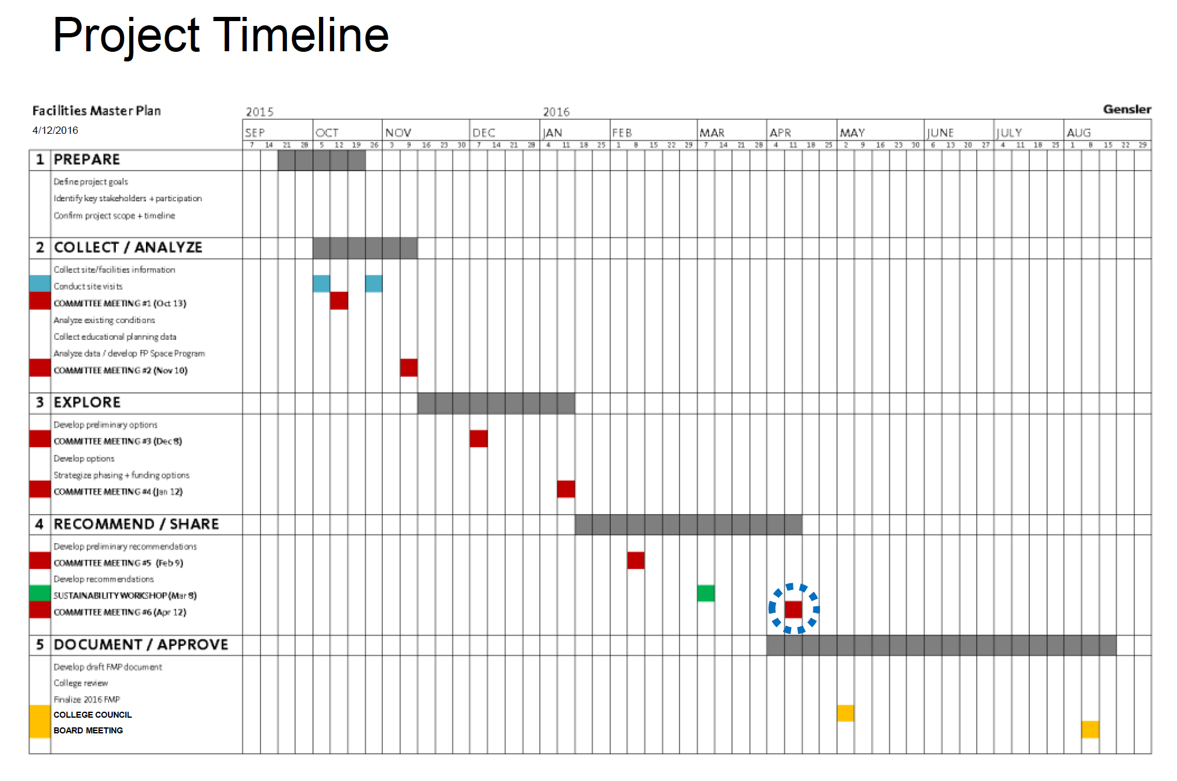

De Anza FMP pg 4

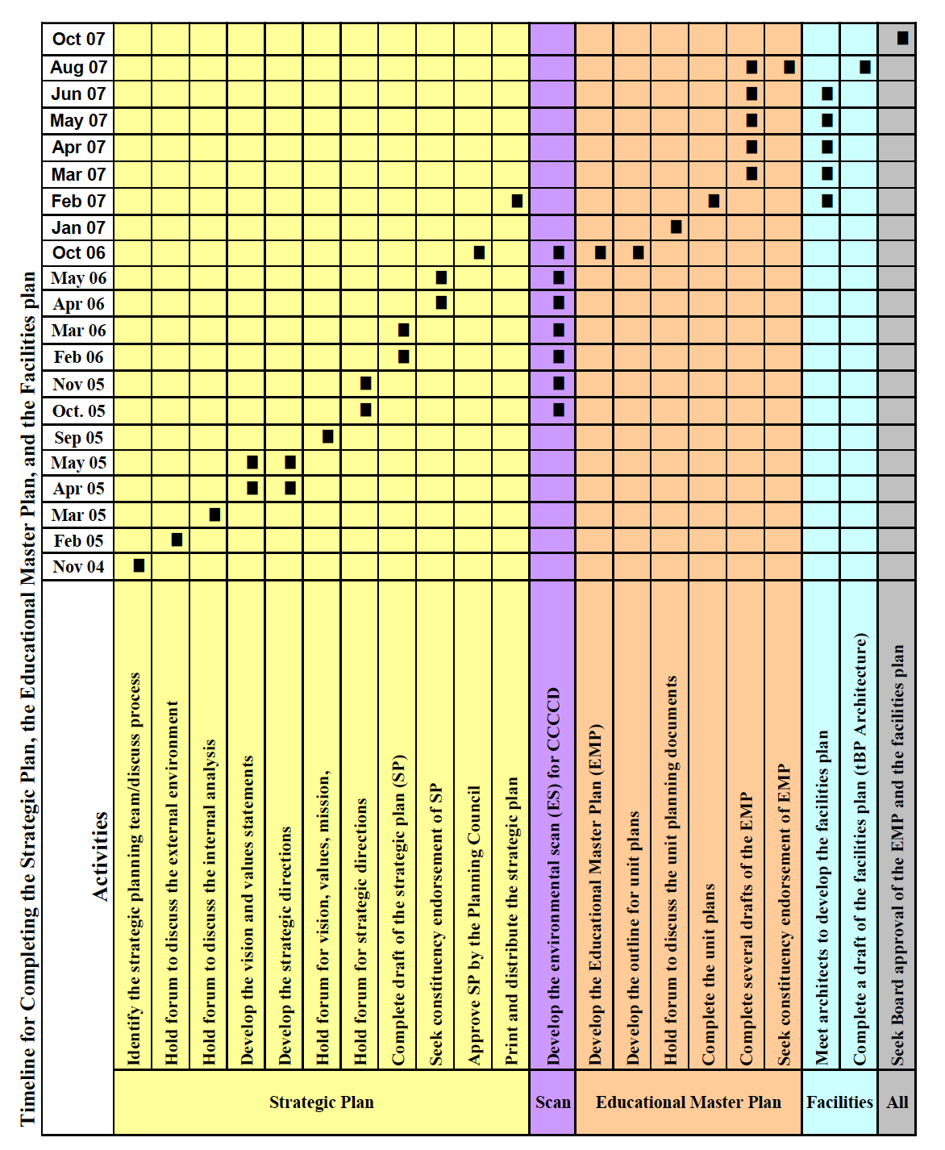

DVC EDMP pg 33

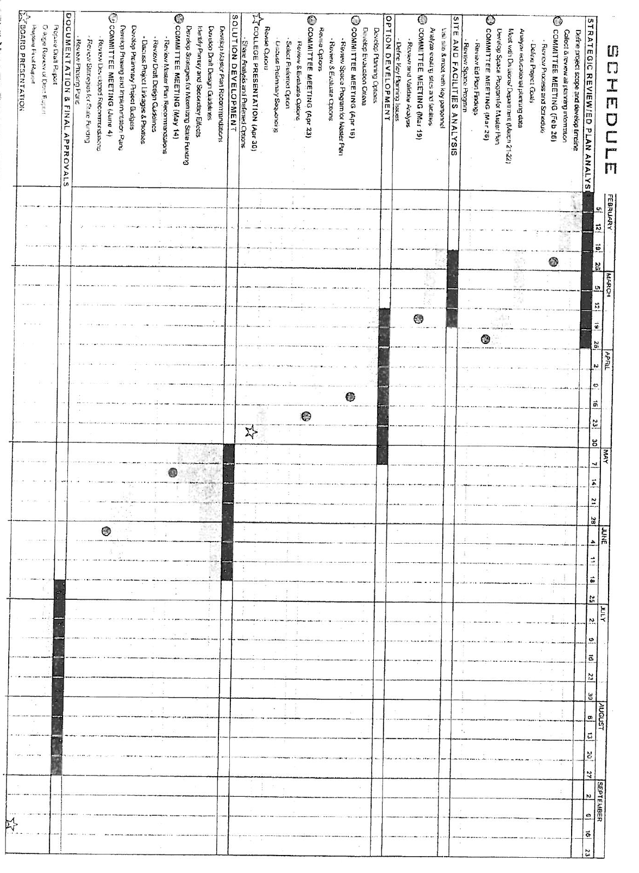

DVC FMP Schedule pg 11

# Fiscal Year Gantt Chart

A Gantt chart is a useful way of showing activities, tasks, or events across time. The position and length of a bar depicts the start date, duration, and end date of the activity as well as activity overlap with one quick glance. Gantt charts can be used for an individual project or to lay out multiple projects across the campus.

Create your Gantt chart by filling in an activity, person, and groups responsible. Then shade in the months during which the activity happens or insert a shape.

Change the heading titles to fit your colleges planning needs.

|  |  |  |  |  |  |  |  |  |  |  |  |  |  |
| --- | --- | --- | --- | --- | --- | --- | --- | --- | --- | --- | --- | --- | --- |
| Activity | Responsible Party | YYYY | | | | | | | YYYY | | | | |
| June | July | Aug | Sep | Oct | Nov | Dec | Jan | Feb | March | April | May |
| Progress update to president | PAC | ◆ |  |  |  | ◆ |  |  |  | ◆ |  |  |  |
| Standards team training | ASC/Writing teams |  |  |  |  |  |  |  |  |  |  |  |  |
| Teams complete outline draft and recommendations | Writing teams |  |  |  |  |  |  |  |  |  |  |  |  |
| Initial drafts to writing teams | Writing teams |  |  |  |  |  |  |  |  |  |  |  |  |
| Progress update to PAC | PAC |  |  |  | ❖ |  |  |  |  |  | ❖ |  |  |
| Draft to campus community | ASC |  |  |  |  |  |  |  |  |  |  |  |  |
| Progress update to Board | BOT |  |  |  |  |  |  |  |  |  |  |  |  |
| Dialogue days and draft feedback | ASC |  |  |  |  |  |  |  |  |  |  |  |  |
| Steering committee retreat | ASC |  |  |  |  |  |  |  |  |  |  |  |  |

# Insert Title

|  |  |  |  |  |  |  |  |  |  |  |  |  |  |
| --- | --- | --- | --- | --- | --- | --- | --- | --- | --- | --- | --- | --- | --- |
| Activity | Responsible Party | YYYY | | | | | | | YYYY | | | | |
| June | July | Aug | Sep | Oct | Nov | Dec | Jan | Feb | March | April | May |
|  |  |  |  |  |  |  |  |  |  |  |  |  |  |
|  |  |  |  |  |  |  |  |  |  |  |  |  |  |
|  |  |  |  |  |  |  |  |  |  |  |  |  |  |
|  |  |  |  |  |  |  |  |  |  |  |  |  |  |
|  |  |  |  |  |  |  |  |  |  |  |  |  |  |
|  |  |  |  |  |  |  |  |  |  |  |  |  |  |
|  |  |  |  |  |  |  |  |  |  |  |  |  |  |
|  |  |  |  |  |  |  |  |  |  |  |  |  |  |
|  |  |  |  |  |  |  |  |  |  |  |  |  |  |
|  |  |  |  |  |  |  |  |  |  |  |  |  |  |
|  |  |  |  |  |  |  |  |  |  |  |  |  |  |
|  |  |  |  |  |  |  |  |  |  |  |  |  |  |
|  |  |  |  |  |  |  |  |  |  |  |  |  |  |

Macintosh HD:Users:Micheline:Desktop:MTSAC_AccreditationTimeline_Timeline-Glance_8-2-16.pdf

Mt SAC – found on web